Name : Lau Tee Ken (n9532897)

Personal Portfolio

I am TeeKen Lau, currently studying computer science. The application project for my team 42 is Media Vault, media storage website to store relevant media files, including songs, images, and pdf and videos. The several contribution with short brief explanation I had made on this web application project is shown at below.

The contribution :

- Recycle bin

- Calculation of total storage used

- Head photo upload

- Link Sharing

- Private Media Session

The supporting documents such as source code is included within my folder name TeeKen Lau ( n9532897) in Git.

1.0 Recycle bin

The first contribution I had done to this project is recycle bin. The users able to delete their unwanted files into thrash for temporary storage until another permanent storage is take place in web page of recycle bin. The connection database between upload and bin is connected for temporary or permanent delete from items of users. The users to remove the unwanted files to recycle bin to recover online used storage. The source code related database connection and code implementation for removing and deleting between respective pages is available under my folder. The figure below is the interface of page I had done.
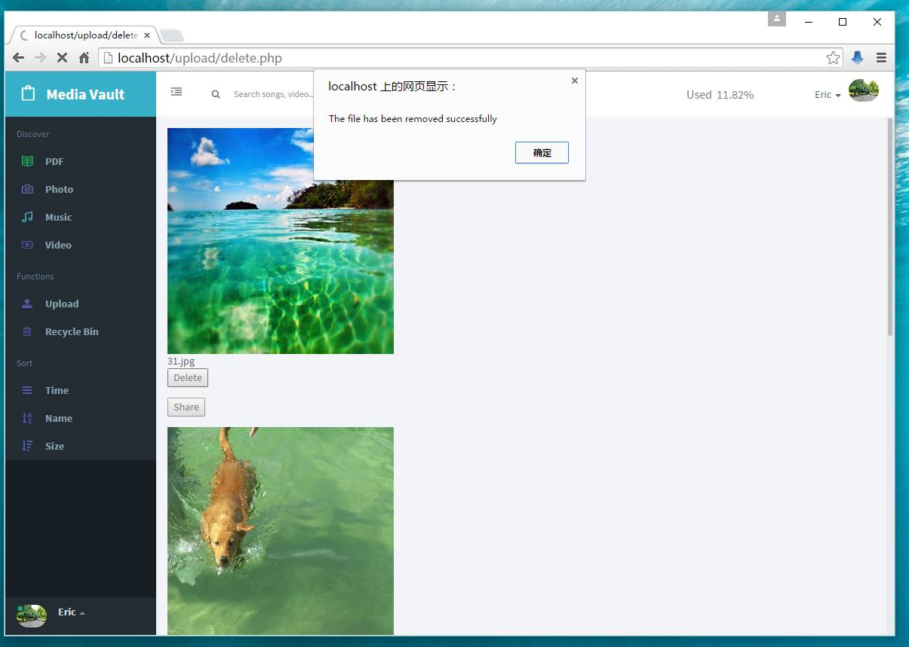

File moved to bin

Figure 1.0

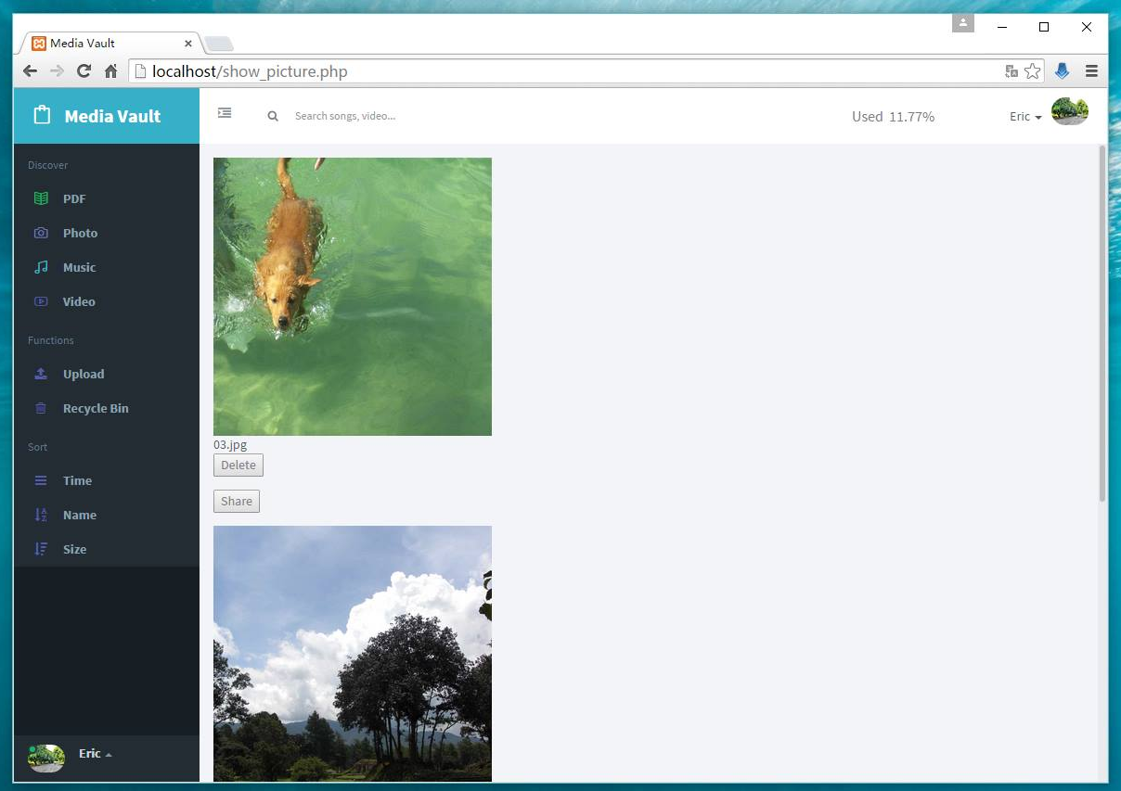

File moved to bin already

Figure 1.1

2.0 Calculation of total storage used

Second of all contribution which is calculating the total storage used by different users. This is very important as good reminder the users whenever the storage is at least and not available to store more wanted files. The calculation of storage used is updated when any action such as delete, remove and upload unwanted and wanted files are performed. The source code related to calculate the storage used and connection to database for total usage of stored files is implemented in order to calculate and update the storage used for every time when different or respective web page is running.The several interface of pages is at the figure provided below.

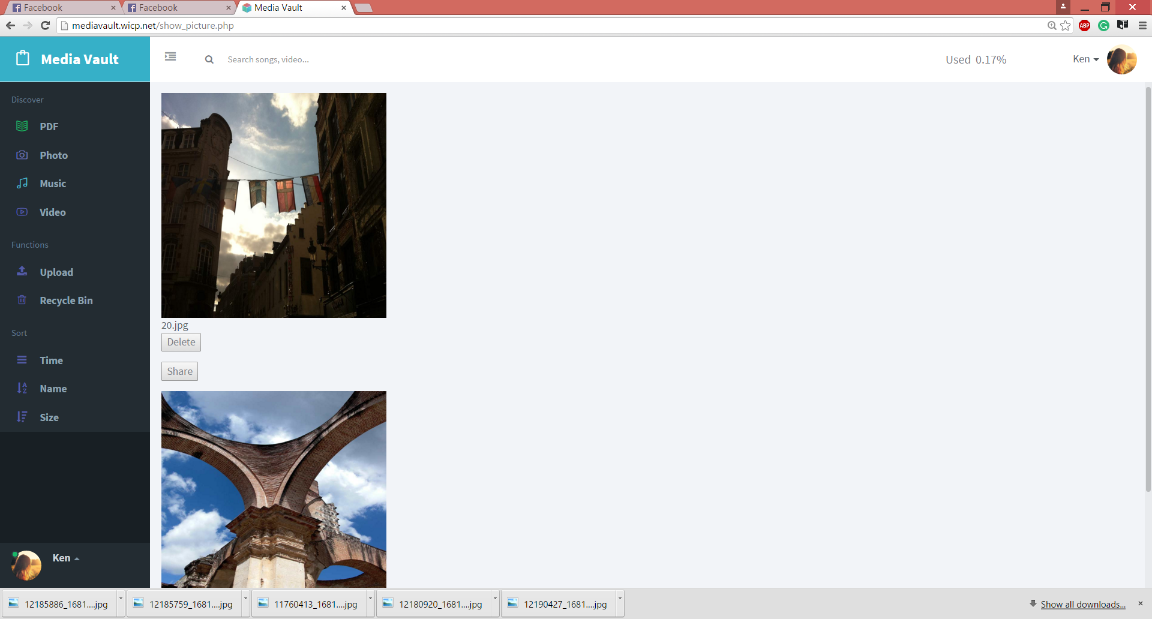

Total storage used

Figure 2.0

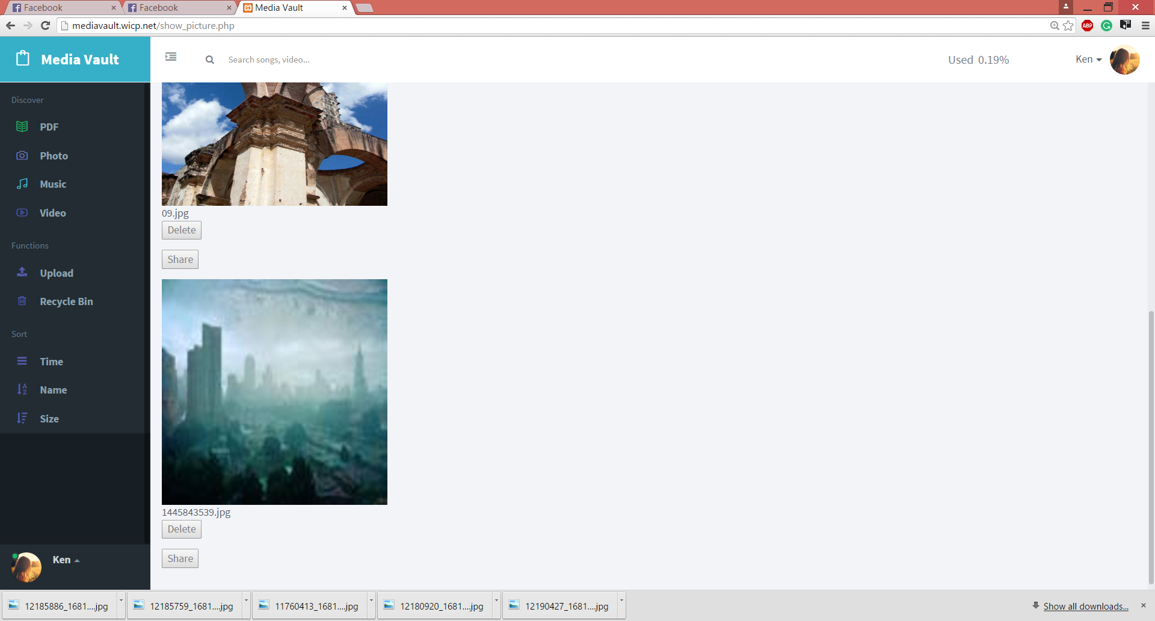

Successful uploading
Total storage used updated

Figure 2.1

3.0 Head photo upload

Head photo uploading is available for different users for their own account and online storage which is my third contribution. The users able to upload or update their new picture as head photo for their own account. The uploading and updating of head photo is only available in profile setting. The head photo will automatically updated once they have uploaded the proper and allowed picture in terms of file size and type. The written code to enable the file to be uploaded and link of picture in our database and server to be connected is available under my folder. The figure provided below is different interfaces of page before and after of head photo has been uploaded.

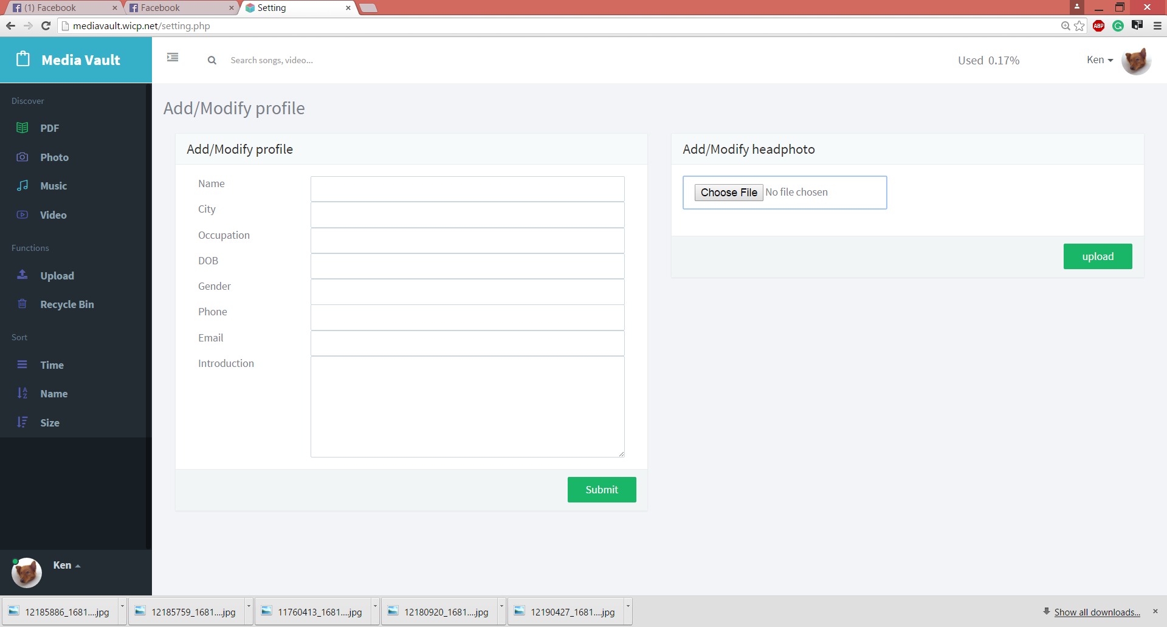

Successful

Figure 3.0

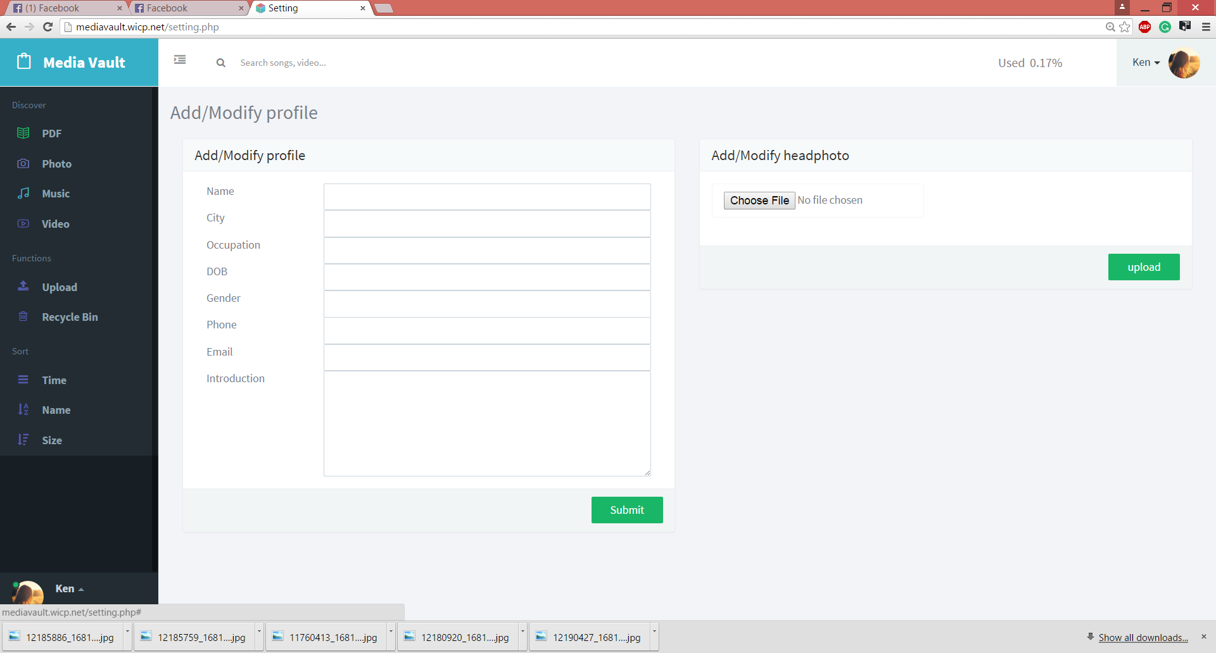

Head photo updated

Figure 3.1

4.0 Link sharing

Link sharing is my fourth contribution. The link sharing is available for some users to copy the desired link of their wanted files in order to share to anyone. The users able to get the link of their files for sharing after the sharing button is performed. The source code implemented in order to connect the data in our database for corresponding of files and capture the desired link for shared files in the prompt box which allow users copy the link. The interface of pages is provided at figure below.

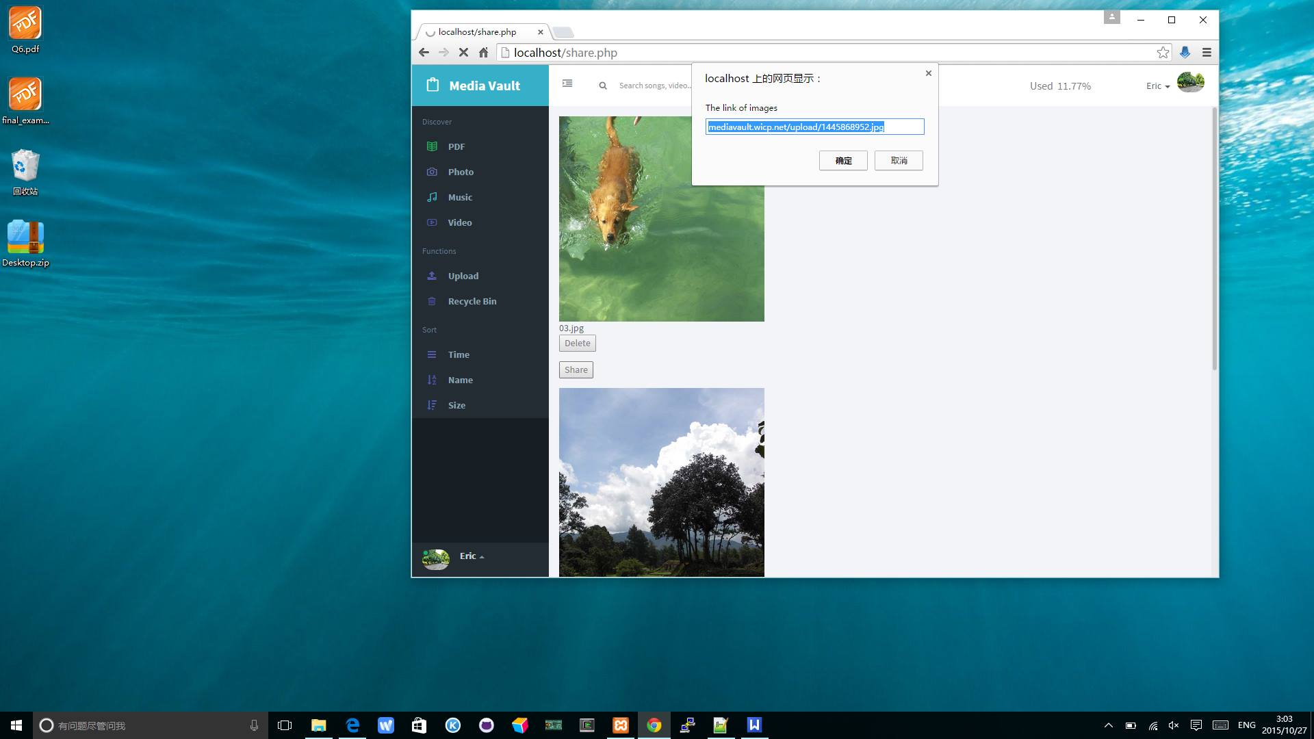

Link Sharing

Figure 4.0

5.0 Private media session

The last and the most important contribution I had done is private media session. The users has different account and different stored files. I have implement code related to user id recognition for every media file to display in different pages related to identity has been logged in after starting of session. The code is written to connect to database and getting value of user id from database in order to do comparison and determine which media files are belong to users. The figure provided below is the comparison of private media session related to different stored files between different users.
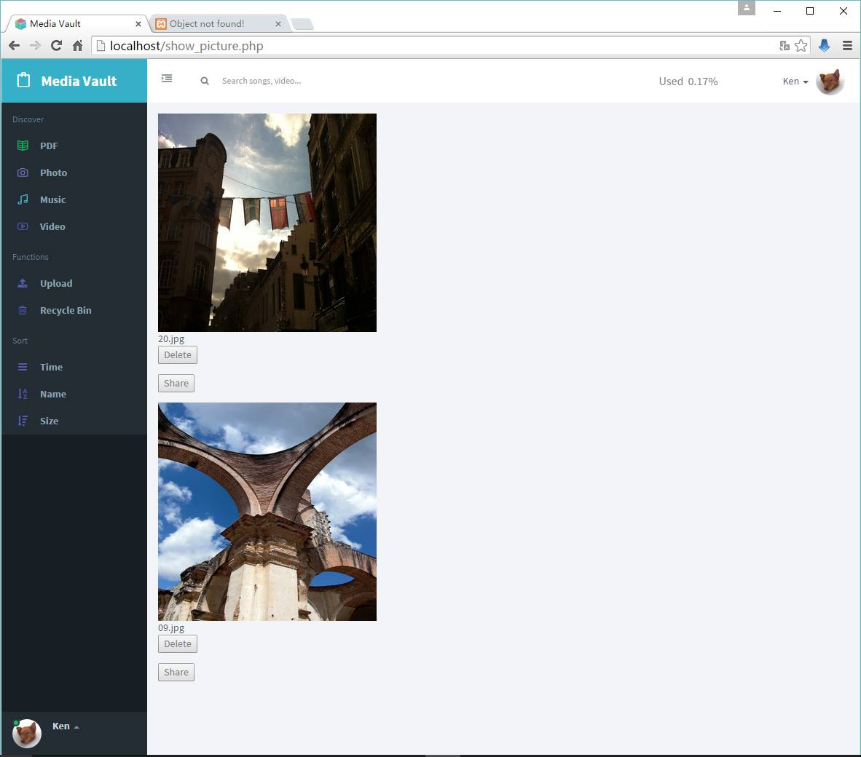

Private media session
Successful

Figure 5.0

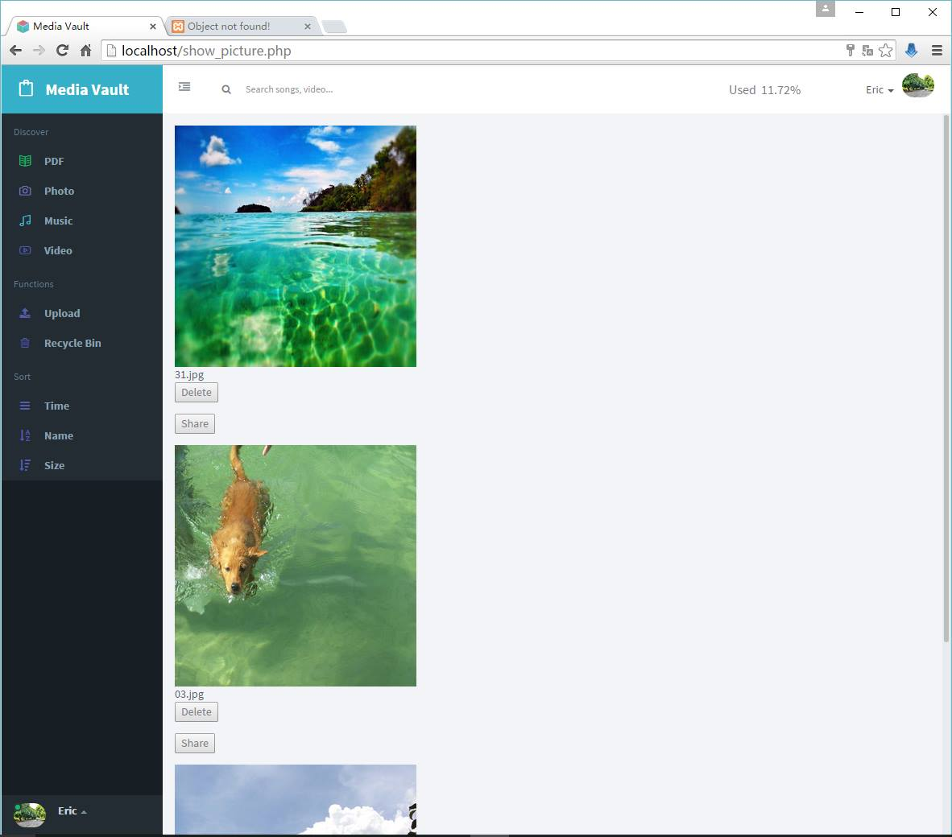

Private media session

Figure 5.1

